Instructions
Requirements according to the work order
Must
- The database can:
  - Save the users with their first name, last name, email and password
  - Save the different nodes with their name, the owner and the date on which it was assigned to the plant species
  - Save plant species
  - Save the measurements
  - Save the tasks
- The documentation contains the MCD and the MLD
User A user (eng. Operator) is a person who can log in to the system. The login to the website is done by e-mail in combination with a password.
A user also has a first name & last name.

Nodes A node is responsible for a maximum of one plant species. Each node can have a name. If a node is planted, it contains the date on which it was assigned to the plant species. Each node has an owner. The default owner of a node is the user "admin@ecample.com" (id=1). For unique identification, each node has a MAC address.

Plant species A plant species (eng. Variety) is defined by its common name. A botanical name can also be given. To optimally supply plants with light and water, we store the optimal threshold values for brightness and soil moisture for each plant species.
Guideline values for air temperature and humidity can also be stored.

Measurements A measurement contains various sensor data that captures thefollowing values:
• Soil moisture (indicates the moisture in the soil)
• Air temperature (detects the temperature of the environment)
• Humidity (measures the water vapor content in the air)
• Brightness (lumens) (indicates light intensity)
• State of the light (shows in percentage how much the node's grow light is set)
In addition, the timestamp is recorded, which indicates the exact time of the measurement, as well as the node affiliation, which indicates which node the data comes from. If a measurement cannot be read or is outside a reasonable range, it is stored as NULL.

Tasks The system & users give up tasks that the nodes must do. A task
corresponds to either lighting or watering. Values between 0-500 can be
specified as quantities. Each task has a due date and time, which is "now"
by default. New tasks are always "not done" by default. A task is marked as
complete once it is completed.
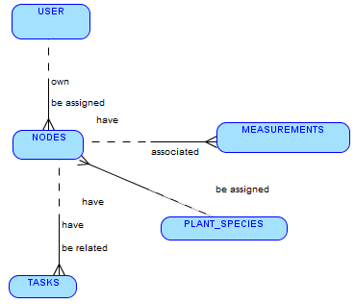
Each USER must own one or more NODES. Each NODES must be assigned to one and only one USER.
Each PLANT-SPECIES must be assigned to one or more NODES. Each NODES must be assigned to one and only one PLANT.
Each NODES must have one or more MEASUREMENTS. Each MEASUREMENTS must be associated with one and only one NODES.
Each TASKS must be related to one and only one NODES. Each NODES must have one or more TASKS.
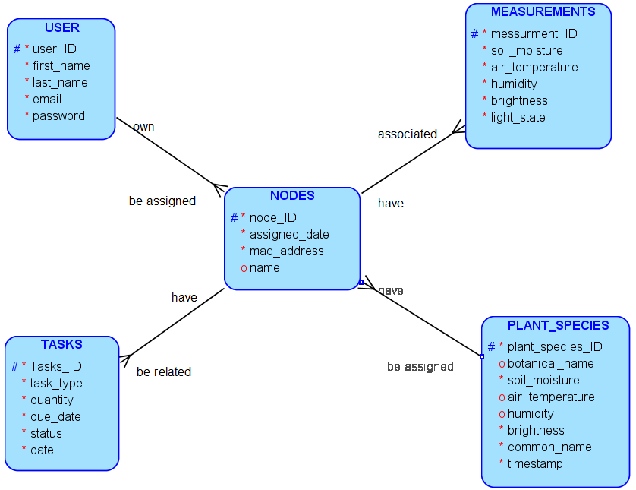

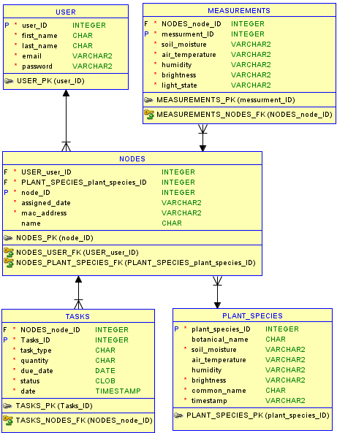
- Mapping the relationships
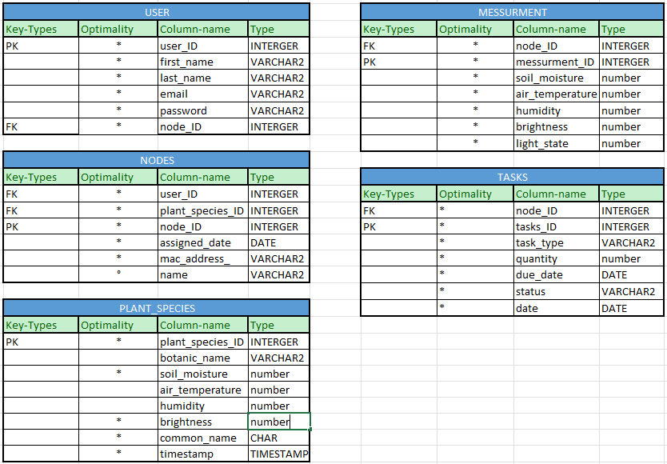
- Create the matrix diagram
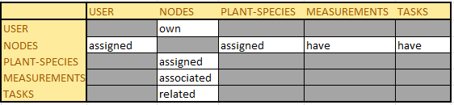
- For each relationship write the sentences
Each USER must own one or more NODES. Each NODES must be assigned to one and only one USER.
Each PLANT-SPECIES must be assigned to one or more NODES. Each NODES must be assigned to one and only one PLANT.
Each NODES must have one or more MEASUREMENTS. Each MEASUREMENTS must be associated with one and only one NODES.
Each TASKS must be related to one and only one NODES. Each NODES must have one or more TASKS.

- Using Apex, create the table for each entity
USER
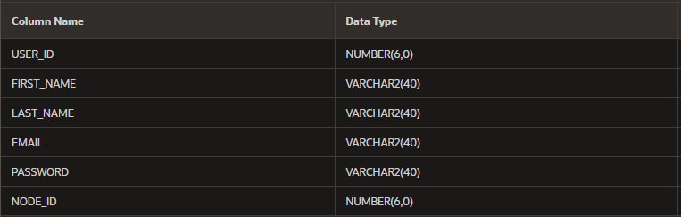
MESSURMENT
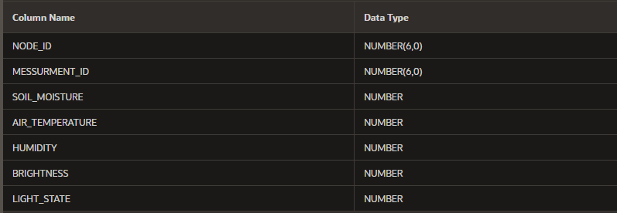
NODES
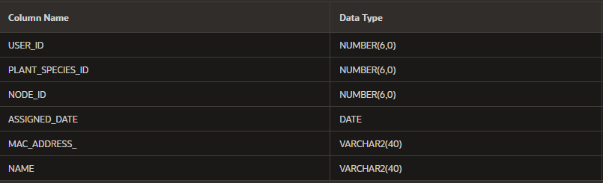
TASKS
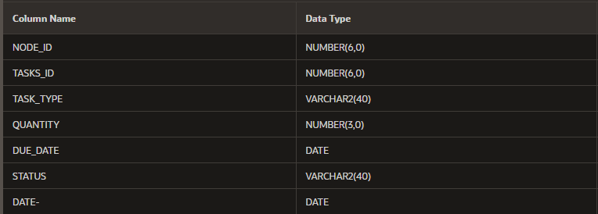
PLANT_SPECIES
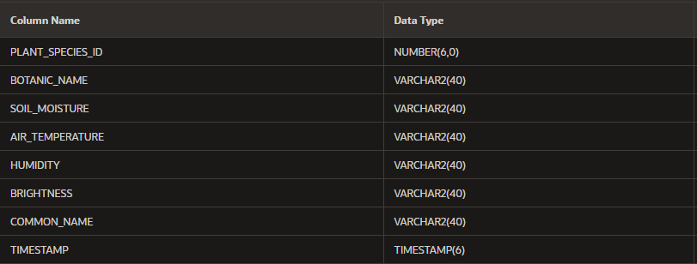

- Each table must contain at least 5 records
